**Readers Home :**

**Home Page : You should login to see the animation on home page**



**NAVBAR:**

**FILTER: Provide many choices for book filtering like book Title, book Language etc...**

**Home: link to the home page.**

**About Us: link to the about readers home section.**

**Books: show all books in the library with search and filter option.**

**Contact Us:** contact **our library team using email and whatsapp.**

**Cart: show all reserved book with an option to remove reservation.**

**Dashboard: private section can access by the admins of the library only to manage library operation such as add, remove books or show users, show borrowing history.**

**Account: provide two main services login and logout.**

**USE EMAIL** [**admin@email.com**](mailto:admin@email.com)

**PASSWORD moh123**

**To login as an admin(to be an admin,the role should be entered manually to the database to protect from users logging in as admins)**

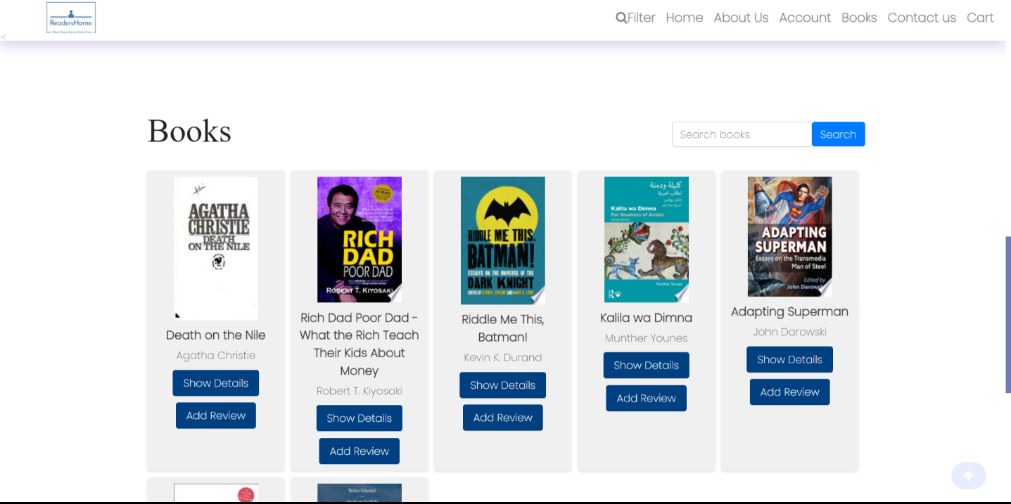Books section to display books information with the availability of show more details about book

And add rating and review.

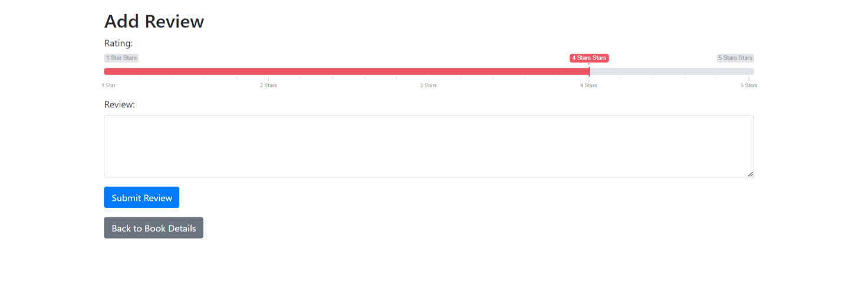

Add review by filling in the text box and choose the rating.

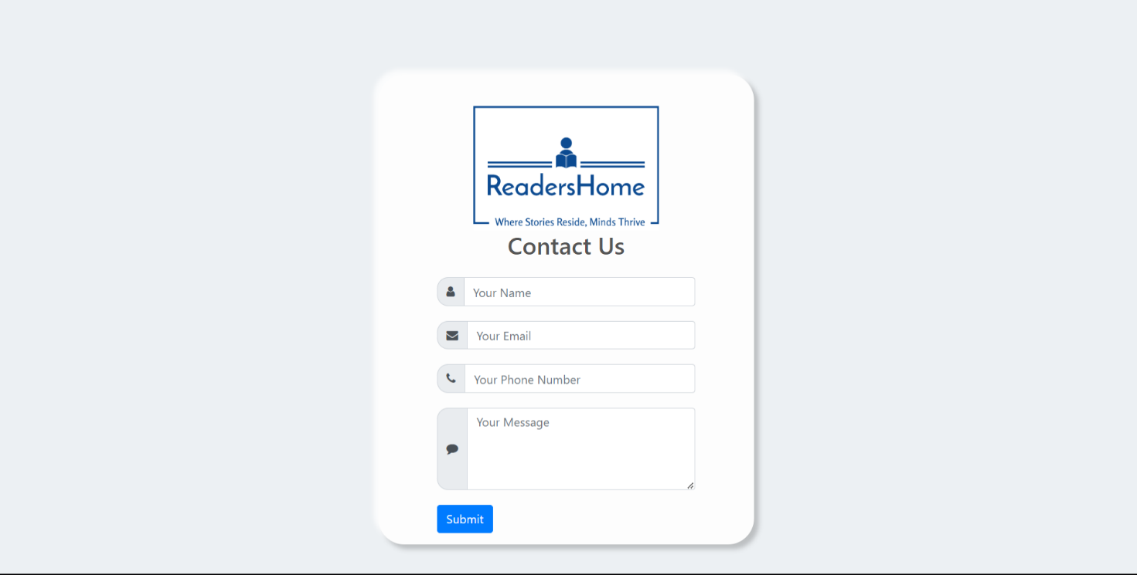Contact to us by providing your name and your email and your phone number and were happy to recive your message.



After clicking on show details on a book you can now reserve this book to read by clicking on the Reserve button.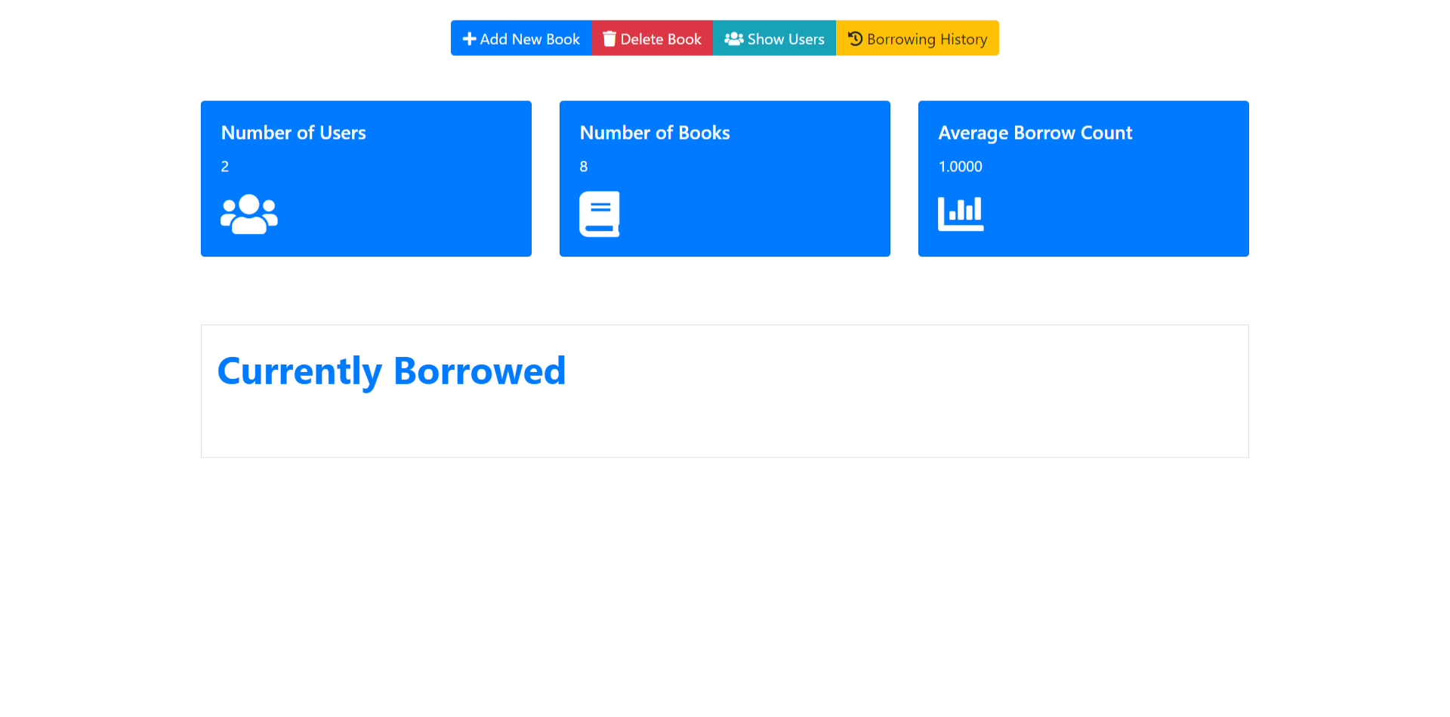The admin dashboard shows number of users and of books and the average of books borrowing

And many services like add new book and delete book and show users and the borrowing history.

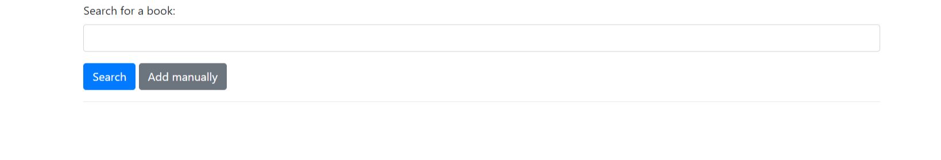

Insert book by two ways one using the google api and one by add the data manually.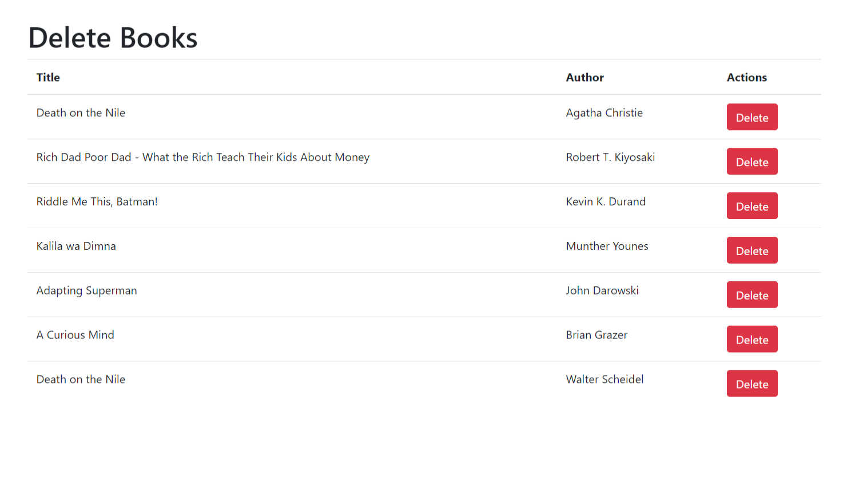Delete book from the library by clicking on delete button.

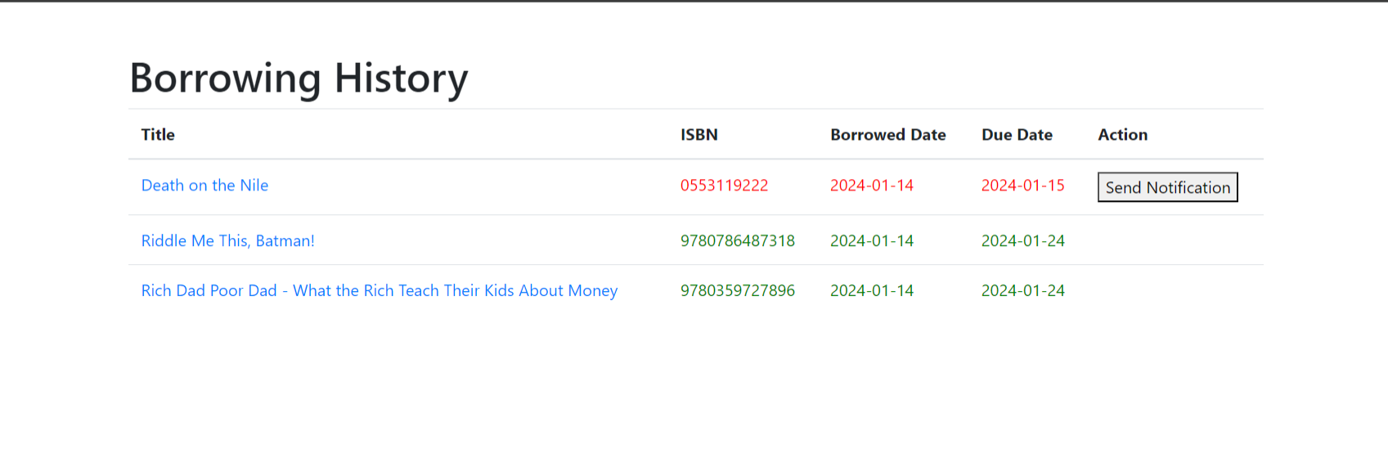Show borrowing history and send notification to the past due date by click on send notification by email.

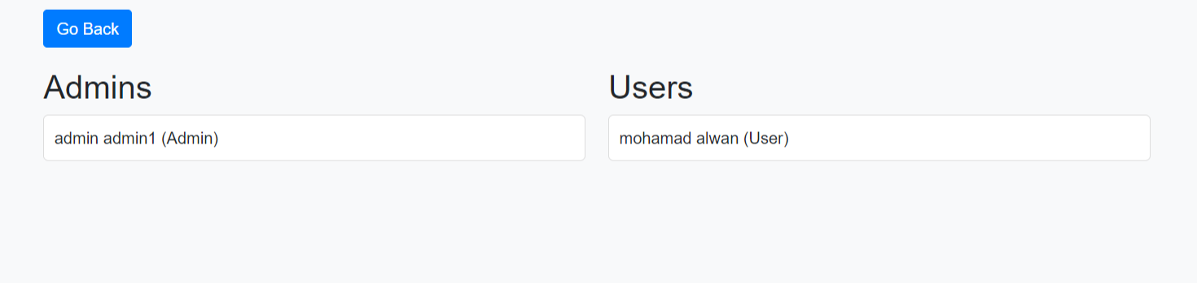Show all users and admins in the system.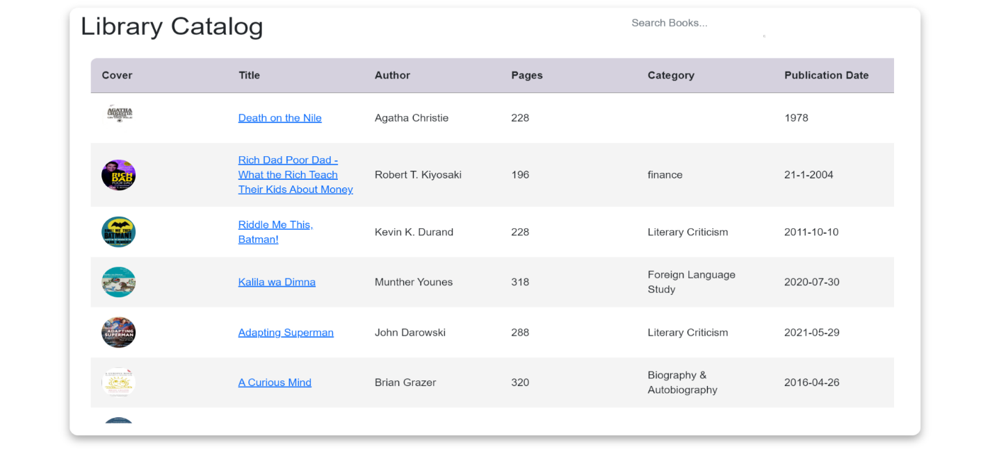Show books and Filtering books using many filters Go filter and choose your book.You can click on TITLE,COVER,AUTHOR,DATE to sort .Try it!!

Show your reserved book from your cart.

Done By :

Mohamad Jamal Alwan

Mustafa Mohamad Almheimid

Dana Akram Al Haj Hassan

Hiba Anwar Esber